B.Sc. DEGREE EXAMINATION, APRIL 2017.
III YEAR — V SEMESTER
Major Paper XII — GRAPH THEORY
Time : 3 hours Max. Marks : 75
SECTION A — (10 × 2 = 20 marks)
Answer any TEN questions
- When two graphs are said to be isomorphic?
- Define cut vertex and cut edge.
- Define Hamiltonian cycle in a graph.
- How the weight of a path is calculated?
- Define “TREE” and “ leafnode “
- Define Bipartite graph.
- When a graph is called planner graph?
- Define Dual graph.
- What is proper colouring in graph theory?
- What is Chromatic number χ(G)?
- When a graph is said to be regular?
- Define subgraphs.
SECTION B — (5 × 5 = 25 marks)
Answer any FIVE questions
- Prove that “A graph G with n vertices, n−1 edges and no cycles is connected.”
- A connected graph G is an Euler graph if and only if all vertices of G are of even degree.
- If G is bipartite, then χ’ (G) =Δ(G).
- Every connected graph has atleast one spanning tree.
- Prove that “If a graph (connected or disconnected) has exactly two vertices of odd degree, there must be a path joined by these two vertices.”
- Prove that “A tree with n vertices has n−1 edges.”
- State and prove Euler’s formula for graphs.
SECTION C — (3 × 10 = 30 marks)
Answer any THREE questions
- Check whether the graphs given are isomorphic or not
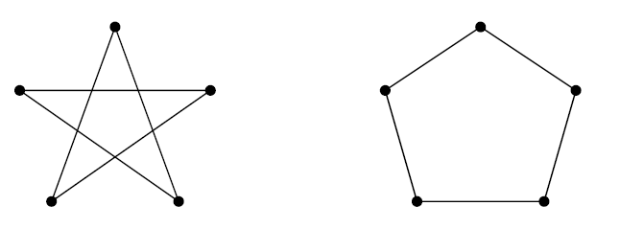
- Prove that A connected graph has an Euler trail if and only if it has atmost two vertices of odd degree.
- State and prove Hall’s Theorem.
- Prove that A graph G is planar if, and only if, G contains no subgraph homeomorphic with K₅ or K₃ , 3 .
- Prove that “Every planar graph is 5-colorable.5”
__________

